What Readers are Saying

Soccer On Sunday In The Park

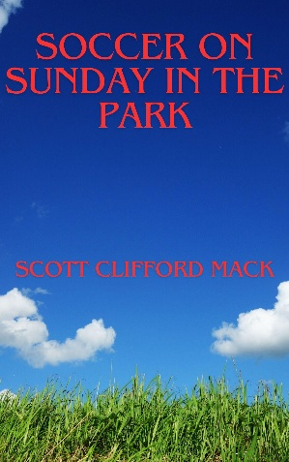

“The author has used soccer as a lens to explore humanity, relationships, and meaning.”

“A tapestry of voices, moments, and lessons woven through the rhythm of weekly matches.”

“Heartwarming and inspiring.”

Adventures of a Forgotten Man



“A reflective and emotionally grounded narrative.”

“Adventures of a Forgotten Man is a quiet, thoughtful, exploration of identity, labor, and invisibility in the modern corporate world. It is not a loud critique of corporate culture, but a resonant one.”

“A story full of surprises.”

